Homework

Answer the questions by SQL.

1. List all the employees whose salaries are more than 3000.

SELECT \* from EMP where sal >= 3000

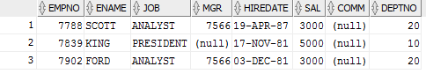

1. List all the employees whose names begin with “S”.

SELECT \* from EMP where ename LIKE 'S%';

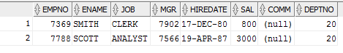

1. List the employees whose name is “SMITH”, “ALLEN” or “FORD”.

SELECT \* from EMP where ename IN ('SMITH','ALLEN','FORD');

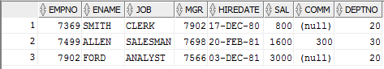

1. List all the employees whose department is “SALES”.

SELECT \* FROM dept INNER JOIN EMP on dept.deptno = emp.deptno where dept.dname='SALES';

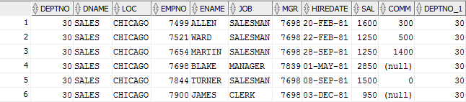

1. To get the value of average, biggest, smallest and total of each department, and order by department number.

SELECT dept.deptno, AVG(sal), MAX(sal), MIN(sal), SUM(sal) FROM emp, dept

WHERE emp.deptno = dept.deptno GROUP BY(dept.deptno)

ORDER BY dept.deptno asc;

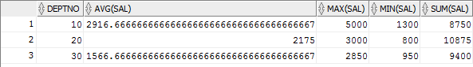

1. To get the total number of employees, whose salary is more than 3000 for each department.

SELECT COUNT(\*) AS "NUMBERofEmployees",deptno,sal FROM emp where sal >=3000 GROUP BY (deptno,sal);



1. To get the number of the average salary for each department, according to the department name in ascending order

SELECT dept.dname,AVG(sal)

FROM emp INNER JOIN dept

on emp.deptno = dept.deptno GROUP BY dept.dname

ORDER BY dept.dname asc;

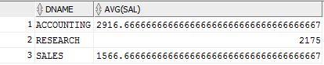

1. List the statistics of employees who have the same salary in each department, list their department number, salary, and number of employees.

SELECT d.dname, e.sal, COUNT(e.ename) FROM emp e, dept d, emp e2

WHERE e.deptno = d.deptno AND e.sal = e2.sal AND e.ename != e2.ename

GROUP BY(d.dname, e.sal);

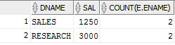

1. List the number of employees with more than 2 employees in the same department, showing the name of the Department, the name of the area, and the number of the employees in the same department

SELECT d.deptno, d.dname, d.loc, COUNT(e.ename) FROM emp e, dept d

WHERE e.deptno = d.deptno HAVING COUNT(e.ename) > 2

GROUP BY(d.deptno, d.dname, d.loc);

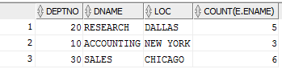

1. List the name and salary of employees whose salaries is higher than the average salary of the entire firm

SELECT ename, sal FROM emp WHERE sal > (SELECT AVG(sal) FROM emp);

